TCP ECHO SERVER AND CLIENT (C)
- C Program (tcp_echo_server.c):
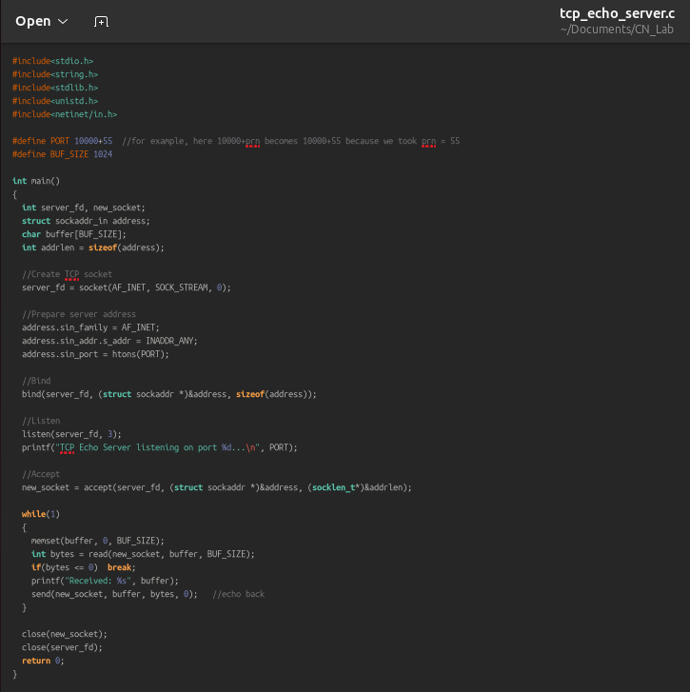

- C Program (tcp_echo_client.c):
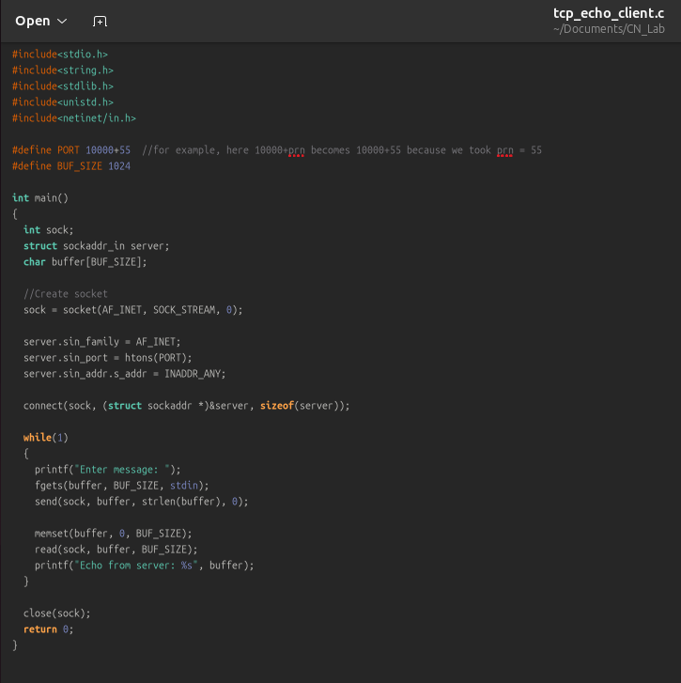

- Output:




